WEEK 3 INTERNSHIP REPORT
Statistical Analysis and Hypothesis Testing in Python
Titanic Passenger Dataset
Statistical evidence for survival differences by gender and age
Environment: Google Colab
Libraries: Pandas, NumPy, SciPy, Matplotlib, Seaborn

1. Executive Summary
This report applies inferential statistical methods to the cleaned Titanic passenger dataset. The overall survival rate in the analyzed data is 41.36%. Two questions were tested. First, a Chi-Square Test of Independence examined whether passenger gender and survival were associated. The test produced χ² = 204.64, df = 1, and p < 0.001, providing very strong evidence of an association. Second, Welch's independent two-sample t-test compared mean age between survivors and non-survivors. The mean ages were 28.32 and 30.54 years respectively, with t = -2.210 and p = 0.0275. The 95% confidence interval for the difference (survivors minus non-survivors) was [-4.19, -0.25] years. Both tests reject their null hypotheses at α = 0.05.

2. Objective
The objective is to use statistical analysis to determine whether patterns observed in the Titanic data are supported by statistical evidence. The analysis combines descriptive statistics, visualizations, hypothesis tests, p-values, and a confidence interval.

3. Dataset Description
The analysis uses the cleaned Titanic dataset prepared during Week 1. Missing values had already been handled and duplicate records removed. The Week 3 notebook confirms zero remaining missing values and zero duplicate rows.
Check | Result
Missing values after cleaning | 0
Duplicate rows | 0
Overall survival rate | 41.36%
Female survival rate | 74.06%
Male survival rate | 21.72%

4. Research Questions and Hypotheses

4.1 Question 1 — Gender and Survival
Does passenger gender have a statistically significant relationship with survival on the Titanic?
H₀: Gender and survival are independent; there is no statistically significant association.
H₁: Gender and survival are not independent; there is a statistically significant association.
Significance level: α = 0.05.

4.2 Question 2 — Age and Survival
Is the average age significantly different between passengers who survived and passengers who did not survive?
H₀: The mean age of survivors and non-survivors is equal.
H₁: The mean age of survivors and non-survivors is different.
Significance level: α = 0.05.

5. Methodology
A Chi-Square Test of Independence was selected for gender versus survival because both variables are categorical. An independent two-sample t-test with unequal-variance (Welch) correction was selected for comparing mean age between the two survival groups. Visualizations were used before and alongside the tests to communicate the observed patterns. A two-sided 95% confidence interval was calculated for the difference in mean age.

6. Descriptive Analysis
Gender | Did not survive | Survived | Survival rate
Female | 76 | 217 | 74.06%
Male | 382 | 106 | 21.72%
Female passengers had a survival rate of 74.06%, compared with 21.72% for male passengers. This large descriptive difference motivates a formal test of association rather than relying on visual inspection alone.

7. Visualization Evidence
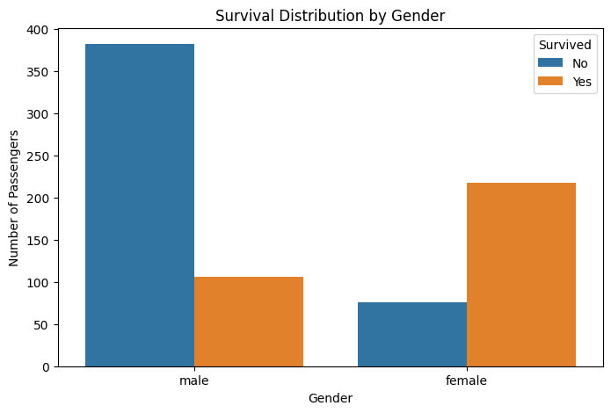
Figure 1. Survival distribution by gender.
Narrative value: This chart gives an immediate visual comparison and motivates the Chi-Square test.
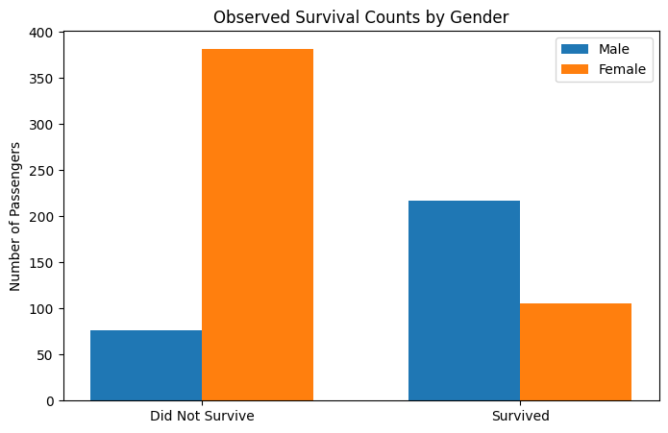
Figure 2. Observed survival counts by gender.
Narrative value: These are the observed counts used in the categorical analysis.
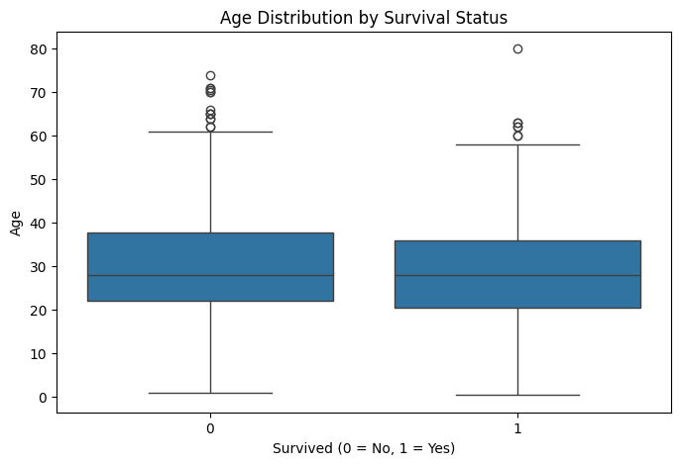
Figure 3. Age distribution by survival status.
Narrative value: The box plot compares the central tendency and spread of age between survival groups.
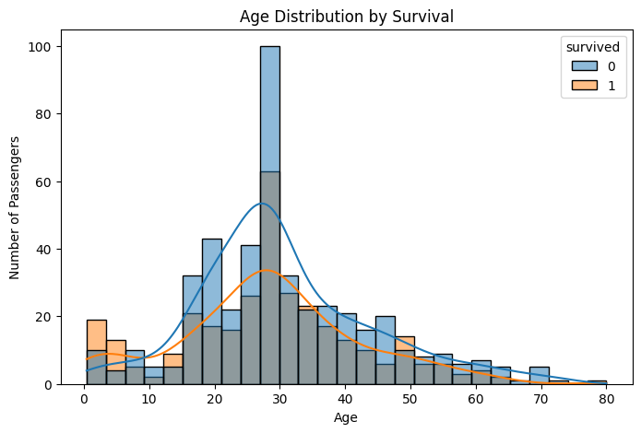
Figure 4. Age distribution by survival.
Narrative value: The histogram adds distribution shape and density information to support the t-test.

8. Chi-Square Test of Independence
The contingency table used for the test was:
Gender | Did not survive | Survived
Female | 76 | 217
Male | 382 | 106
contingency_table = pd.crosstab(df["sex"], df["survived"])
chi2, p_value, dof, expected = chi2_contingency(contingency_table)
Result: χ² = 204.64, degrees of freedom = 1, p-value = 2.027e-46. Because the p-value is far below 0.05, the null hypothesis is rejected. There is statistically significant evidence of an association between gender and survival in this dataset.
The result should be interpreted as an association, not as proof that gender alone caused the survival difference. Other factors, including passenger class and age, may also contribute.

9. Independent Two-Sample T-Test
Group | Mean age (years)
Survivors | 28.32
Non-survivors | 30.54
t_stat, t_p_value = ttest_ind(
survived_age,
not_survived_age,
equal_var=False
)
Result: t = -2.210, p-value = 0.0275. Since p < 0.05, the null hypothesis is rejected. The sample provides statistically significant evidence that mean age differs between survivors and non-survivors.

10. 95% Confidence Interval
The estimated mean difference (survivors minus non-survivors) is -2.22 years. The 95% confidence interval is [-4.19, -0.25] years.
Because the confidence interval does not include zero, it is consistent with the t-test conclusion that the mean ages differ statistically at the 5% significance level. The negative interval indicates that, in this sample, survivors had a lower mean age than non-survivors.

11. Statistical Results Summary
Test | Statistic | p-value | Decision at α=0.05 | Conclusion
Chi-Square: Gender vs Survival | χ²=204.64 | 2.027e-46 | Reject H₀ | Significant association
Welch T-Test: Age vs Survival | t=-2.210 | 0.0275 | Reject H₀ | Significant mean-age difference

12. Interpretation for a Non-Technical Audience
The statistical tests strengthen what the charts suggest. The gender comparison is extremely unlikely to be explained by random variation alone under the independence assumption. The age comparison also provides evidence of a real difference in average age between the two survival groups in this dataset. Statistical significance, however, should not be confused with causation or practical importance.

13. Business and Scientific Implications
The workflow demonstrated here is useful beyond historical passenger data. In business analytics, Chi-Square tests can help evaluate whether customer outcomes differ across categories such as product type, region, or customer segment. T-tests can compare average spending, response time, or other continuous measures between two groups. In scientific research, the same framework supports evidence-based comparison of groups and helps distinguish observed patterns from random variation. Visualizations make the statistical findings easier to communicate to stakeholders.

14. Limitations
- The Titanic dataset is historical and should not be generalized to modern populations.
- Statistical association does not establish causation.
- Age values were cleaned in Week 1 using preprocessing, so the age analysis depends partly on those preprocessing decisions.
- The analysis focuses on two-variable questions; other variables may confound or explain the observed relationships.
- Formal effect-size analysis, assumption diagnostics, and multivariable modeling could provide additional evidence.

15. Conclusion
The Week 3 analysis successfully applied two inferential statistical methods to the cleaned Titanic dataset. The Chi-Square test found a statistically significant association between gender and survival (χ²=204.64, p=2.027e-46). The Welch t-test found a statistically significant difference in mean age between survivors and non-survivors (t=-2.210, p=0.0275), with a 95% confidence interval of [-4.19, -0.25] years for the mean difference. Together, the results show how descriptive patterns can be evaluated rigorously using hypothesis testing, while also emphasizing that statistical significance is not the same as causation.

16. Python Code Appendix
import pandas as pd
import numpy as np
import matplotlib.pyplot as plt
import seaborn as sns
from scipy.stats import chi2_contingency, ttest_ind
df = pd.read_csv("titanic_cleaned.csv")
contingency_table = pd.crosstab(df["sex"], df["survived"])
chi2, p_value, dof, expected = chi2_contingency(contingency_table)
survived_age = df[df["survived"] == 1]["age"]
not_survived_age = df[df["survived"] == 0]["age"]
t_stat, t_p_value = ttest_ind(
survived_age, not_survived_age, equal_var=False
)
Report prepared from the submitted Week 3 Google Colab notebook and its recorded outputs.

